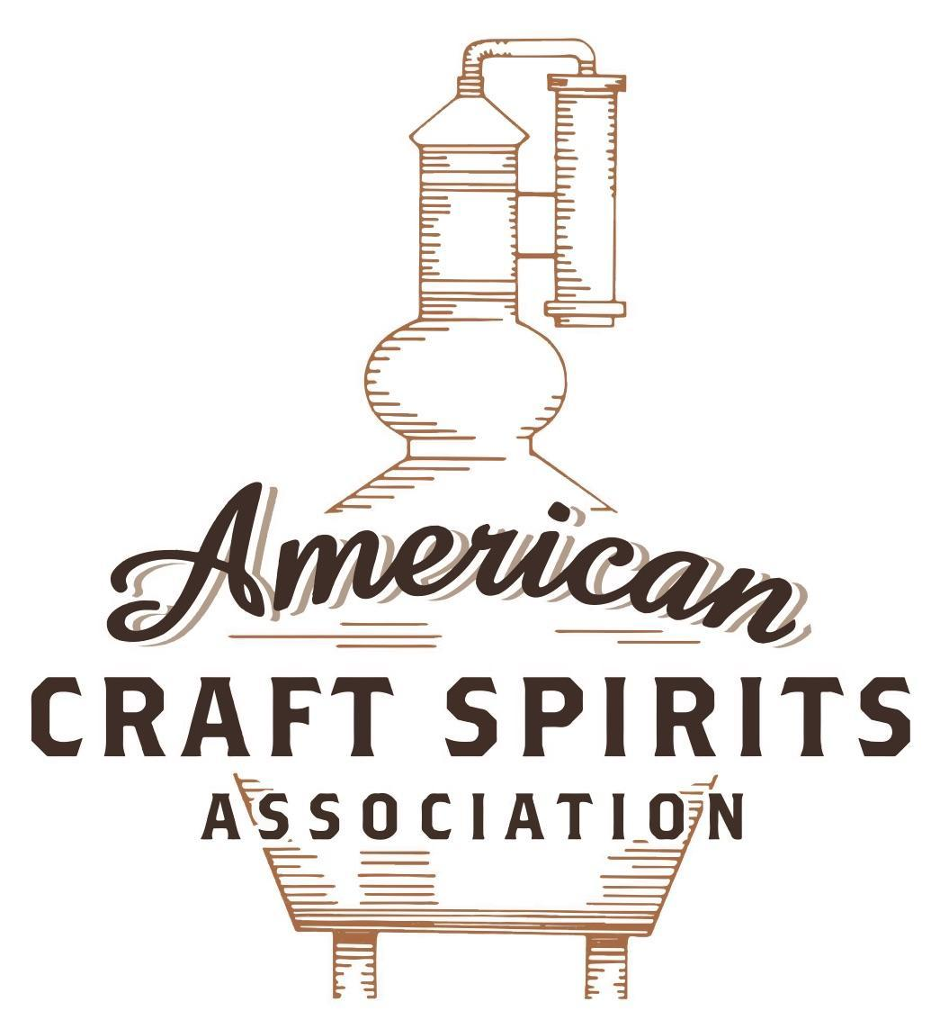
Spirits DtC Shipping Guide

This guide summarizes the direct-to-consumer shipping rules for distilleries in all 50 states and D.C. and also addresses the measures state governments have taken to ease delivery and shipping restrictions during the COVID-19 pandemic.

DtC Quick Guide Comparison

Out-of-State Distilleries  Can Ship Into State? |  |  |  | In-State Distilleries  Can Ship Within State?
State | Yes | No |  | State | Yes | No
AL |  | X |  | AL |  | X
AK | X |  |  | AK | X
AZ | X |  |  | AZ | X
AR |  | X |  | AR |  | X
CA |  | X* |  | CA |  | X*
CO |  | X |  | CO |  | X
CT |  | X* |  | CT |  | X
DE |  | X |  | DE |  | X
DC | X |  |  | DC | X
FL |  | X |  | FL |  | X
GA |  | X |  | GA |  | X
HI |  | X* |  | HI |  | ?*
ID |  | X |  | ID |  | X
IL |  | X* |  | IL |  | X*
IN |  | X |  | IN |  | X
IA |  | X* |  | IA |  | X*
KS |  | X |  | KS |  | X
KY | X |  |  | KY | X
LA |  | X |  | LA |  | X
ME |  | X* |  | ME |  | X*
MD |  | X |  | MD |  | X
MA |  | X |  | MA |  | X
MI |  | X |  | MI |  | X
MN |  | X |  | MN |  | X
MS |  | X |  | MS |  | X
MO |  | X |  | MO |  | X
MT |  | X |  | MT |  | X
NE | X |  |  | NE | X
NV |  | X* |  | NV |  | X
NH | X |  |  | NH |  | X*
NJ |  | X* |  | NJ |  | X*
NM |  | X |  | NM |  | X
NY |  | X* |  | NY |  | X*
NC |  | X |  | NC |  | X
ND | X |  |  | ND | X
OH |  | X |  | OH |  | X
OK |  | X |  | OK |  | X
OR |  | X |  | OR | X
PA |  | X* |  | PA |  | X
RI |  | X* |  | RI |  | X
SC |  | X |  | SC |  | X
SD |  | X |  | SD |  | X
TN |  | X |  | TN |  | X
TX |  | X |  | TX |  | X
UT |  | X |  | UT |  | X
VT |  | X |  | VT |  | X
VA |  | X |  | VA |  | X
WA |  | X* |  | WA | X
WV |  | X* |  | WV |  | X*

WI |  | X |  | WI |  | X
WY |  | X |  | WY |  | X

Notes:
*CA: If passed and signed into law, Senate Bill 620 would allow licensed distilled spirits producers in states other than California and licensed distilled spirits manufacturers or craft distillers in California who obtain distilled spirits direct shipper permits to ship directly to consumers in California
*CT: Consumers with appropriate permit may receive alcohol shipments
*HI: Consumers with appropriate permit may receive alcohol shipments; If passed and signed into law, Senate Bill 65 would allow licensed distilled spirits manufacturers in Hawaii and in states other than Hawaii who obtain direct shipper permits to ship directly to consumers in Hawaii
*IL: If passed and signed into law, Senate Bill 0532 would allow licensed distilled spirits producers in Illinois and in states other than Illinois who obtain distillery shippers’ licenses to ship directly to consumers in Illinois
*IA: If passed and signed into law, House File 639 would allow native distilled spirits manufacturers in Iowa and in states other than Iowa who obtain direct shipper permits to ship directly to consumers in Iowa and to consumers in states other than Iowa
*ME: If passed and signed into law, Legislative Document 1358 would allow distilleries outside of Maine with current manufacturer licenses and distilleries licensed in Maine who obtain spirits direct shipper licenses to ship directly to consumers in Maine
*NJ: (1) If passed and signed into law, Assembly Bill 3167 would allow a craft distillery licensees to ship no more than 9 liters of distilled spirits to a consumer in New Jersey; (2) If passed and signed into law, Senate Bill 3020 would allow craft distillery licensees in New Jersey or in states other than New Jersey to ship no more than 20 liters of distilled spirits to a consumer in New Jersey via common carrier
*NV: Licensed individuals can import one gallon per month of spirits for personal use and the out-of-state supplier must pay excise tax
*NH: If passed and signed into law, Senate Bill 125 would allow licensed liquor manufacturers who obtain direct to consumer shipping permits from the commission to ship directly to consumers in New Hampshire
*NY: Consumer may import up to 90L of liquor per year for personal use without a license; If passed and signed into law, Assembly Bill 3275 would allow licensed liquor manufacturers in states other than New York and licensed distillers and farm distillers in New York to ship no more than thirty-six cases (no more than nine liters per case) of liquor to consumers in New York
*PA: Consumer may place a special liquor order and distiller must ship to a PLCB-operated store
*RI: Distiller can only ship to customer if order was personally placed by customer at distiller's premises
*WA: If passed and signed into law, House Bill 1432 would allow licensed spirits manufacturers in states other than Washington to ship spirits to consumers in Washington
*WV: Distilleries, mini-distilleries, or micro-distilleries licensed in West Virginia or a state other than West Virginia who obtain private direct shipper licenses to ship to a consumer in West Virginia, however the shipments must be made to a retail liquor outlet

WYOMING
Shipment Outbound – Silent.
Shipment Inbound – No, the WY Liquor Division is the exclusive wholesale distributor and seller of alcoholic liquor within Wyoming. (Wyo. Stat. § 12-2-301(a)).
Shipment Intra-state – No, however, manufacturers may sell liquor to consumers at their licensed premises and at no more than two satellite locations (Wyo. Stat. § 12-5-201; § 12-2-203).
COVID-19 Measures – The Department of Revenue waived penalty and interest for severance taxes that are filed late through the month of June. Sales and use tax filings will be handled on a case by case basis.
Link: https://drive.google.com/file/d/1nERE7Lh-vlSSU2Btu1oXxnVDr2OQ5MBk/view
Citation (shipment)
WY Statutes
12-2-301. Generally.
(a) Except as provided in W.S. 12-2-203(g), the division is the exclusive wholesale distributor and seller of alcoholic liquor within Wyoming. It is granted the sole right to sell alcoholic liquors at wholesale, and no licensee or permittee who is granted the right to sell, distribute or receive alcoholic liquors at retail shall purchase any alcoholic liquors from any source other than the division, unless as authorized pursuant to W.S. 12-4-201(j) or as otherwise expressly authorized by state law. Any out-of-state shipment of alcoholic liquor or malt beverage into this state is prohibited unless otherwise expressly authorized by state law.
12-5-201. Location, regulation and restrictions as to place of sale; inspections.
(a) Except as otherwise provided in this section, the principal place in which alcoholic liquor and malt beverages are sold under a license shall be located in the licensed building for which the license is issued and as approved by the licensing authority. Alcoholic beverages may be served only in the licensed building and in an immediately adjacent fenced or enclosed area as approved by the local licensing authority. This adjacent area shall not be in another building. The licensing authority shall, as often as necessary, inspect the licensed building and adjacent areas where alcoholic beverages are served to insure that the licensee is in compliance with sanitation and fire hazard requirements and other applicable laws.
12-2-203. Manufacturing and rectifying; importing and industry representatives; licensing; fees.
(g) The local licensing authority may issue to the holder of a manufacturer's license granted under subsection (a) of this section who is a federally licensed distiller or rectifier:
(i) A satellite manufacturer's permit which allows the permittee to sell product manufactured at the site identified on the manufacturer's license at not more than two (2) satellite locations within Wyoming separate from its manufacturing site under the original permit. Products sold at a manufacturer's satellite location may be obtained through the division as provided by W.S. 12-2-303(a). If a satellite location is situated within the property boundary of the manufacturing site, the product may be distributed directly from the permit holder's manufacturing site subject to W.S. 12-2-303(d). The satellite manufacturer's permit may be issued on application to the appropriate licensing authority. The local licensing authority may require a public hearing and the payment of an additional permit fee not to exceed one hundred dollars ($100.00) per satellite location. The satellite manufacturer's permit shall be subject to the terms and conditions of W.S. 12-4-106, the schedule of operating hours set pursuant to W.S. 12-5-101 and the licensed building provisions pursuant to W.S. 12-5-201.
Link to WY statutes: https://wyoleg.gov/statutes/compress/title12.pdf

The American Craft Spirits Association (ACSA) is working diligently to give our members and industry partners relevant, current updates on statutes and regulations impacting production, sale and distribution of spirits. With the declaration of the novel coronavirus (COVID-19) in early 2020, many states have issued temporary policy changes or longer-term modernization of alcohol beverage laws. State statutes, regulations created by the state alcohol regulatory authority, as well as any other relevant guidance provided by such authorities (such as advisories, opinions, bulletins, etc.) were reviewed in creation of this document. No city or county ordinances were reviewed. Distillers should be aware that even in states where direct shipping is permissible, always remember to avoid shipping to dry counties. Please consult with your state guild or alcohol beverage authority for the most up-to-date information. This content is intended for educational and informational purposes only. ACSA's pro bono law firm of Malkin Law P.A. provided the core content found in this comprehensive overview of the spirits distribution after COVID-19. It was completed in August 2021 and will be updated regularly. If you have updates you would like to provide, please send to legislation@americancraftspirits.org or directly to the law firm at: ryan@malkin.law / malkin.law. Thank you.
H.B. 13, signed and enacted into law on February 2, 2021, does not permit direct-to-consumer shipping, but the legislation allows a manufacturer licensee with a satellite location to deliver or contract to have delivered their manufactured products to consumers. Sales of alcoholic liquors must take place in the licensed building and orders may be placed by phone, online, or through a mobile application. Deliveries must be completed during the licensee’s operating hours on the same day the alcoholic liquors are removed from the inventory of the licensed premise. Link: https://www.wyoleg.gov/2021/Enroll/HB0013.pdf

